COMPUTER

PROJECT

RAILWAY

RESERVATION

BY: K SRIKANT IYER

CLASS: XI-C

ROLL NO: 20

CONTENTS

1. ACKNOWLEDGEMENTS
2. CERTIFICATE
3. INTRODUCTION
4. OVERVIEW
5. REQUIREMENTS
6. SOURCE CODE
7. SNAPSHOT OF OUTPUT
8. RESOURCES

ACKNOWLEDGEMENT

It is my utmost pleasure to express deep sense of gratitude towards Mrs. Sofia Goel, our computer teacher who directed us to complete this project successfully. Her valuable guidance & support are considerably responsible for helping this project attain present form. I would also duly thank her for letting me use and practice in the school computer lab while working on this project.

CERTIFICATE

VISHWA BHARATI PUBLIC SCHOOL, NOIDA

This is to certify that K. Srikant Iyer, Roll no 20 of class XI-C has successfully completed Computer Project under my supervision according to the guidelines laid down.

Teacher Incharge

INTRODUCTION

This project aims at development of an Online Railway Reservation Utility which facilitates the Railway customers to manage their reservations, and the Railway administrators to modify the backend databases in a User-Friendly manner.

This program has been made completely by using basic c++ language and is easy to access by following the given instructions in the program.

The program uses while & for loops, switch case, functions calling, if command, go to command, arrays, etc. including all types of commands taught in this year.

REQUIREMENTS

* Any windows platform.
* 32 Mb RAM or more.
* Pentium processor at 90 Mhz or higher.
* 200.0Kb free space in Hard Disc.
* **Installed Turbo C++ with graphic libraries.**
* The program executable file.

SOURCE CODE

/******************RAILWAY RESERVATION MACHINE*********************/

#include<iostream.h>

#include<conio.h>

#include<dos.h>

/************************** STRUCTURE ***************************/

struct passenger

{char name[20];

int age;

char gender;

};

/************************** FUNCTION ***************************/

int train()

{clrscr();

int first;

cout<<"(1)Ticket cancellation\n ";

cout<<"(2)Availability\n ";

cin>>first;

//ticket cancellation

if (first==1)

{ clrscr();

float c;

cout<<"Enter your ticket no ";

cin>>c;

cout<<"\nThe ticket number "<<c<<" has successfully been cancelled\n";

}

//ticket availability

else if (first==2)

{ clrscr();

cout<<"This is a holiday special express.\n";

cout<<"This train is available for all days in a week.\n";

cout<<"Timings 2:30am only.\n";

}

}

/************************* PROGRAM ***************************/

void main()

{ start:

clrscr();

int to,first,from,go,opt,n,o,total;

char c,m,k,d;

sound(1000);

delay(900);

nosound();

cout<<" \n\n*-*-*-*-*-*-* Welcome to Indian Railways Point To Point Services *-*-*-*-*-*-*\n";

cout<<" (1)For tickets from Delhi press 1 \n";

cout<<" (2)For tickets from other stops press 2 \n";

cout<<" (3)To exit press 3\n";

cout<<" (4)For other details press 4\n";

loop1:

cin>>first;

//IF FROM DELHI

if (first==1)

{ int to;

clrscr();

cout<<" FROM DELHI TO ...... ";

cout<<" \n\n (1)Press 1 for options of trains from Delhi to Chennai \n";

cout<<" (2)Press 2 for options of trains from Delhi to Mumbai \n";

cout<<" (3)Press 3 for options of trains from Delhi to Kolkata \n";

cin>>to;

switch (to)

{ case 1: clrscr();

cout<<"\n\nOptions for your desired option are :\n";

cout<<" (A)For ticket booking press 1\n " ;

cout<<" (B)For other options press 2\n";

cin>>opt;

if (opt==1)

{ clrscr();

passenger p[20];

cout<<"\n\nCost of 1 adult ticket is Rs2500.\n";

cout<<"Enter the number of adults.\n";

cin>>n;

for (int i=1;i<=n;i++)

{ cout<<"Enter name of passenger ";

cin>>p[i].name;

cout<<"Enter age of passenger ";

cin>>p[i].age;

cout<<"Enter gender of passenger ";

cin>>p[i].gender;

}

cout<<"Cost of 1 child is Rs 2000.\n";

cout<<"Enter the no of children.\n";

cin>>o;

for (int j=1;j<=o;j++)

{ cout<<"Enter name of passenger ";

cin>>p[j].name;

cout<<"Enter age of passenger ";

cin>>p[j].age;

cout<<"Enter gender of passenger ";

cin>>p[j].gender;

}

delay(1500);

total=(2500*n)+(2000*o);

cout<<"\n Your have to pay Rs"<<total;

cout<<"\n Your seat has successfullly been booked!!\n";

}

else if (opt==2)

{train();}

break ;

case 2: clrscr();

cout<<"\n\n Options for your desired option are :\n";

cout<<" (A)For ticket booking press 1\n " ;

cout<<" (B)For other options press 2\n";

cin>>opt;

if (opt==1)

{ passenger p[20];

cout<<"Cost of 1 adult ticket is Rs2500.\n";

cout<<"Enter the number of adults.\n";

cin>>n;

for (int i=1;i<=n;i++)

{ cout<<"Enter name of passenger ";

cin>>p[i].name;

cout<<"Enter age of passenger ";

cin>>p[i].age;

cout<<"Enter gender of passenger ";

cin>>p[i].gender;

}

cout<<"Cost of 1 child is Rs 2000.\n";

cout<<"Enter the no of children.\n";

cin>>o;

for (int j=1;j<=o;j++)

{ cout<<"Enter name of passenger ";

cin>>p[j].name;

cout<<"Enter age of passenger ";

cin>>p[j].age;

cout<<"Enter gender of passenger ";

cin>>p[j].gender;

}

delay(1500);

total=(2500*n)+(2000*o);

cout<<"\n Your have to pay Rs"<<total;

cout<<"\n Your seat has successfullly been booked!!\n";

}

else if (opt==2)

{train();}

break ;

case 3: clrscr();

cout<<"\nOptions for your desired option are :\n";

cout<<" (A)For ticket booking press 1\n " ;

cout<<" (B)For other options press 2\n";

cin>>opt;

if (opt==1)

{ passenger p[20];

cout<<"Cost of 1 adult ticket is Rs2500.\n";

cout<<"Enter the number of adults.\n";

cin>>n;

for (int i=1;i<=n;i++)

{ cout<<"Enter name of passenger";

cin>>p[i].name;

cout<<"Enter age of passenger";

cin>>p[i].age;

cout<<"Enter gender of passenger";

cin>>p[i].gender;

}

cout<<"Cost of 1 child is Rs 2000.\n";

cout<<"Enter the no of children.\n";

cin>>o;

for (int j=1;j<=o;j++)

{ cout<<"Enter name of passenger";

cin>>p[j].name;

cout<<"Enter age of passenger";

cin>>p[j].age;

cout<<"Enter gender of passenger";

cin>>p[j].gender;

}

delay(1500);

total=(2500*n)+(2000*o);

cout<<"\n Your have to pay Rs"<<total;

cout<<"\n Your seat has successfullly been booked!!\n";

}

else if (opt==2)

{train();}

break;}

cout<<"\n(A)Main menu press 1\n(B)Exit press 2\n";

cin>>go;

if(go==1)

{goto start;}

else if (go==2)

{goto end;}

}

//IF NOT FROM DELHI

else if (first==2)

{ clrscr();

cout<<" FROM AND TO ";

cout<<"\n (1)Chennai\n (2)Mumbai\n (3)Kolkata\n (4)Delhi\n ";

cout<<"\n Enter the place of boarding ";

cin>>from;

cout<<" \n Enter the terminal station ";

cin>>to;

cout<<" \nOptions for your desired option are :\n";

cout<<" (A)For ticket booking press 1 \n" ;

cout<<" (B)For other options press 2\n";

cin>>opt;

if (opt==1)

{ passenger p[20];

cout<<" Cost of 1 adult ticket is Rs2500.\n";

cout<<" Enter the number of adults.\n";

cin>>n;

for (int i=1;i<=n;i++)

{ clrscr();

cout<<"Enter name of passenger ";

cin>>p[i].name;

cout<<"Enter age of passenger ";

cin>>p[i].age;

cout<<"Enter gender of passenger ";

cin>>p[i].gender;

}

cout<<"Cost of 1 child is Rs 2000.\n";

cout<<"Enter the no of children.\n";

cin>>o;

for (int j=1;j<=o;j++)

{ cout<<"Enter name of passenger";

cin>>p[j].name;

cout<<"Enter age of passenger";

cin>>p[j].age;

cout<<"Enter gender of passenger";

cin>>p[j].gender;

}

delay(1500);

total=(2500*n)+(2000*o);

cout<<"\n Your have to pay Rs"<<total;

cout<<"\n Your seat has successfullly been booked!!\n";

}

else if (opt==2)

{train();}

cout<<"\n(A)Main menu press 1\n(B)Exit press 2\n";

cin>>go;

if(go==1)

{goto start;}

else if (go==2)

{goto end;}}

//IF HE WANTS TO EXIT

else if (first==3)

{goto end;}

//IF HE WANTS OTHER DETAILS

else if (first==4)

{clrscr();

cout<<" CREDITS";

cout<<"\nEfforts by : K Srikant Iyer\n Class:XI-C\n Roll No:20\n";

cout<<"Special thanks to Mrs Sofia Goel\n for giving this chance to expres our ideas in this project.\n";

cout<<"For any further programing help please contact our office \n";

cout<<"Toll Free :9458868661 OR 9013017661\n";

cout<<"\n(A)Main menu press 1\n(B)Exit press 2";

cin>>go;

if(go==1)

{goto start;}

else if (go==2)

{goto end;}

}

else

{

cout<<"\nPlease enter a valid option\n";

goto loop1;}

end:

cout<<" Thank you for using Indian Railways.Please come again.";

cout<<" Press any key to shut down.";

getch();

}

SOME OUTPUTS

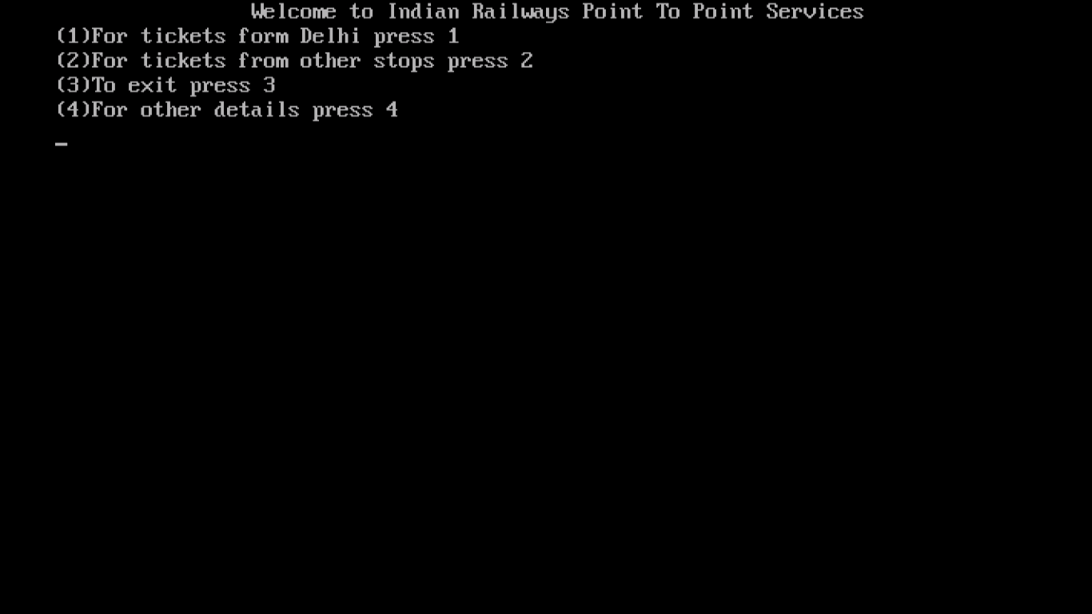

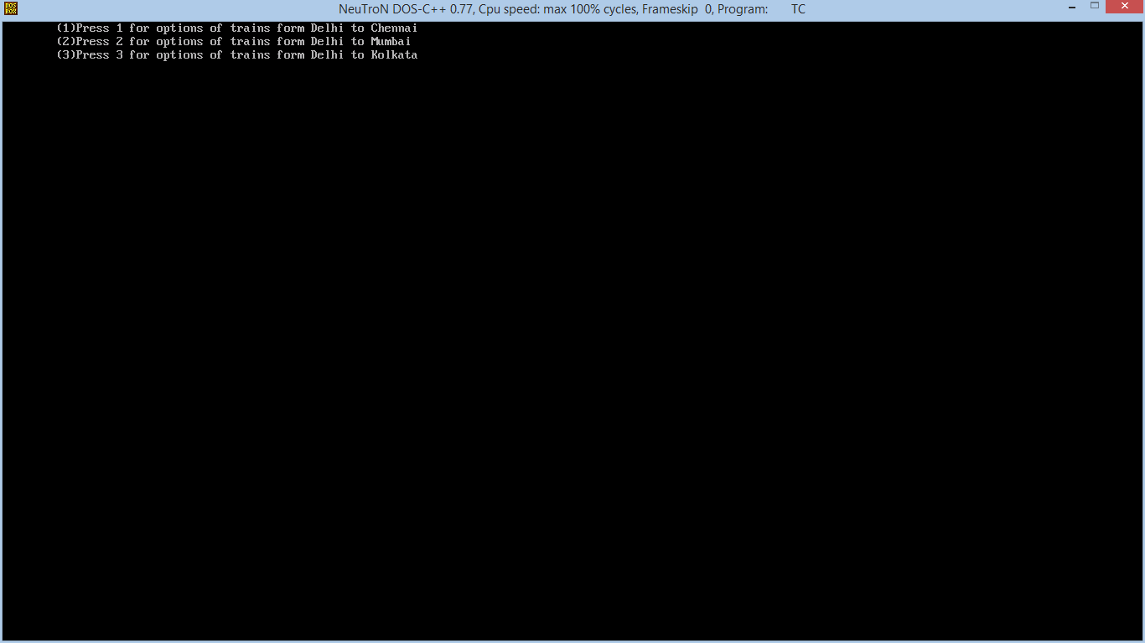

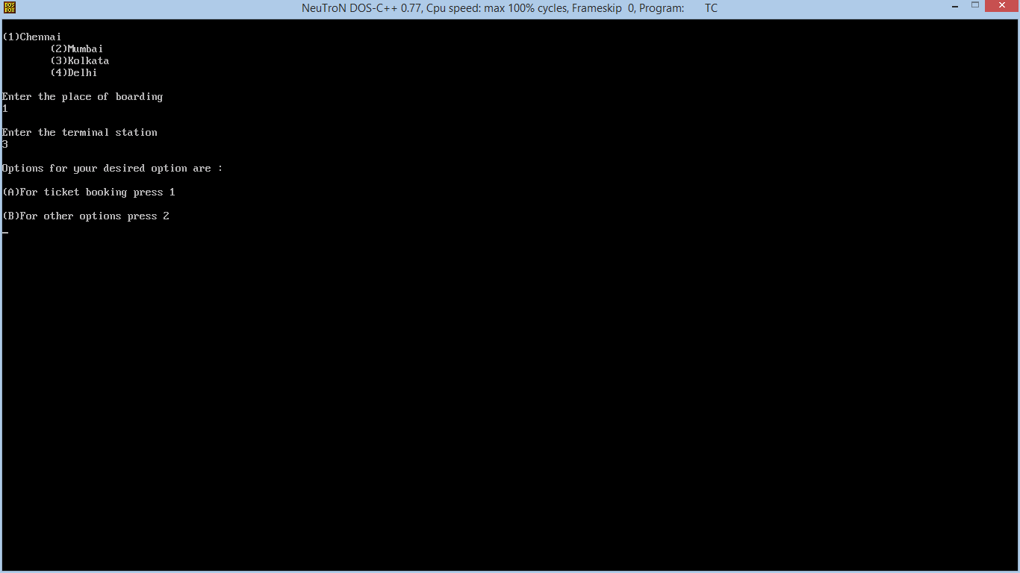

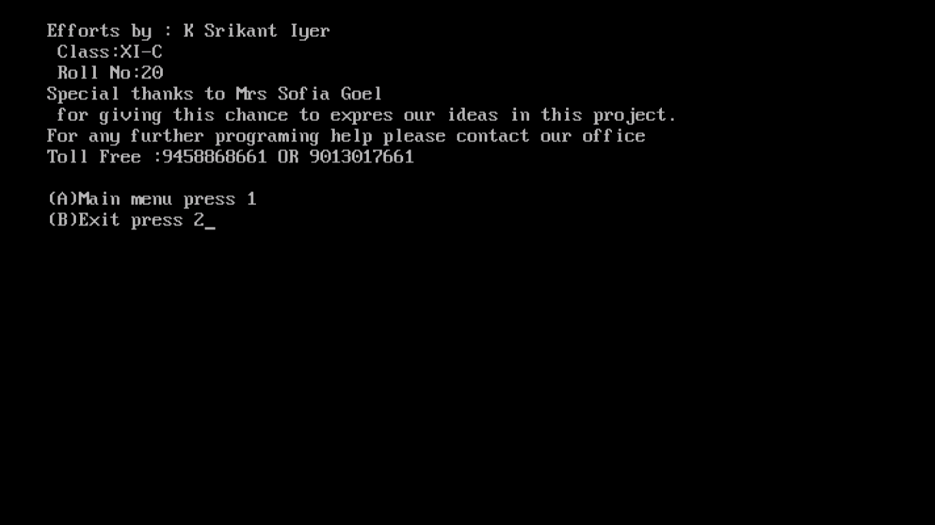

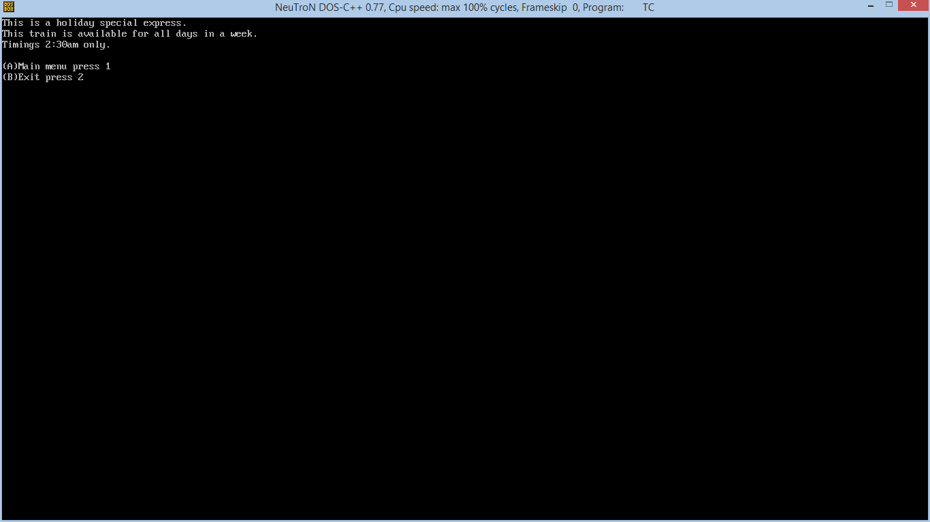

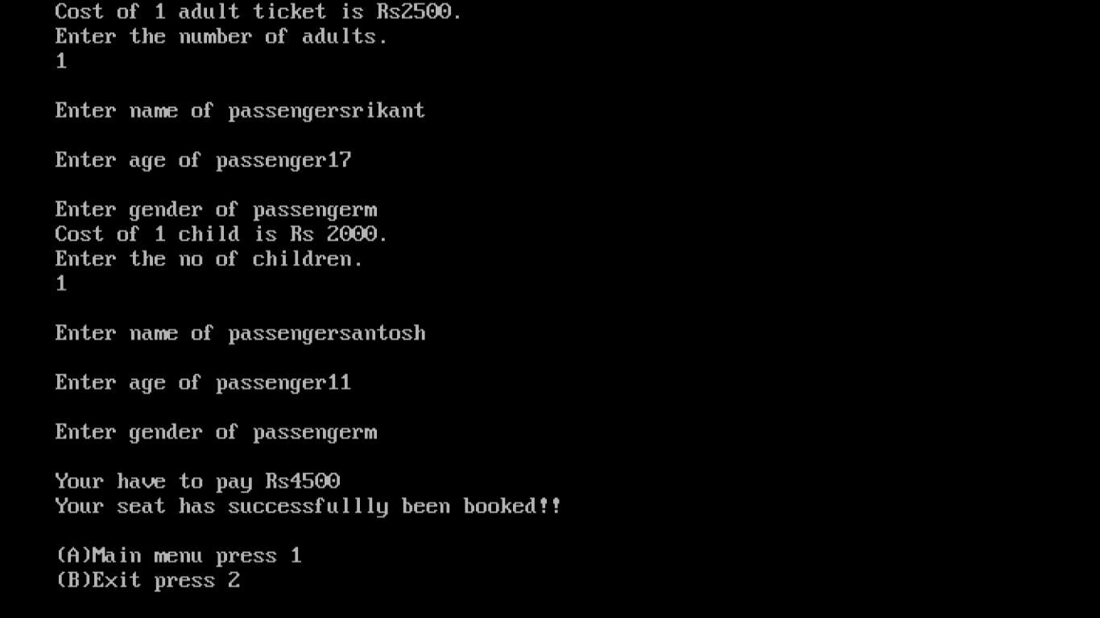

RESOURCES USED

* The ideas used to make this project are completely original and have not been copied from anywhere.
* The basic c++ commands and tricks have been picked up from our book only.
* The school computer.

All the source code is self-written.

THANK YOU FOR USING INDIAN RAILWAY ……….PLEASE COME AGAIN